On of the most important feature of the rust is asynchronous programming. Now it is stable in rust. it is an important feature because it allows us to run different features on the same OS thread instead of spreading the workload on two threads you can use only one.

now let's see how we can implement the async programming in rust

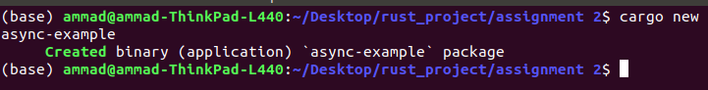First create the new project

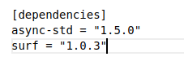then go into the visual code and import the two crates

we are calling async-std because we want to import executor. The surf is used to fetch the data from web site



then include this two program into your program

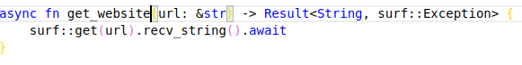

then add the asynchronous function to get the data

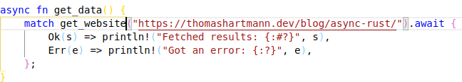

make the new asynchronous function to implement get website function and print the result or if get error print the error.

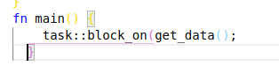

Finally the main function is called remember we can not implement asynchronous function without executor.

Go to the terminal and write cargo run and see the result